**CHAPTER 1**

**INTRODUCTION**

* 1. **PROBLEM DEFINITION**

Selfpaced Learning is an online website which is mainly focuses on employees in Infosys DC’s. The ETA heads need a system that can automatically record and store course-wise session recording which can be referred to by any employees at any point of time. Every online course should be supplemented with the corresponding question bank. After completing a course, the learner must attempt the test in order to achieve a badge-Completed Course.

* 1. **ABOUT THE ORGANIZATION**

Infosys was established by seven engineers in Pune, Maharashtra, India with an initial capital of $250 in 1981. It was registered as Infosys Consultants Private Limited on 2 July 1981. In 1983, it relocated its office to Bangalore, Karnataka, India.

Infosys Ltd is a global technology services firm that defines, designs and delivers information technology (IT)-enabled business solutions to their clients. The company provides end-to-end business solutions that leverage technology for their clients, including technical consulting, design, development, product engineering, maintenance, systems integration, package-enabled consulting, and implementation and infrastructure management services.

The company also provides software products to the banking industry. They have developed Finacle, a universal banking solution to large and medium size banks across India and overseas. Infosys BPO is a majority owned subsidiary. Through Infosys BPO, the company provides business process management services, such as offsite customer relationship management, finance and accounting, and administration and sales order processing. The company is having marketing and technical alliance with FileNet, IBM, Intel, Microsoft, Oracle and System Application Products.

Infosys Ltd is a public limited and India's second largest software exporter company was incorporated in the year 1981 as Infosys Consultants Pvt Ltd by Mr. N.R. Narayana Murthy at Karnataka. The company was started by seven people with the investment of USD 250. The company became a public limited company in the year 1992. The company was the first Indian company to be listed on the NASDAQ in the year 1999. Infosys also forms a part of the NASDAQ-100 index. Continuously in the year 2001, 2002 and 2003, the company wins the National award for excellence in corporate governance conferred by the Government of India.

* 1. **OBJECTIVE OF THE PROJECT**

Selfpaced Learning is an online website which is mainly focuses on employees in Infosys DC’s. The ETA heads need a system that can automatically record and store course-wise session recording which can be referred to by any employees at any point of time. Every online course should be supplemented with the corresponding question bank. After completing a course, the learner must attempt the test in order to achieve a badge-Completed Course.

Using this website an employee can register and login to the website. After login he can start studying the languages as per his/her needs. After completing a particular course the employee can take test and he can score marks. If the employee performed well in the examination then a ranking is allotted to the employee. After completing the course badges is allotted to the employee. For each completed course the employee have that number of badges. The employee can view this badges from his/her profile. After completing a course the employee can generate certificate for that particular course . He can download this certificate from the website .

**CHAPTER 2**

**LITERATURE SURVEY**

**2.1 INITIAL INVESTIGATION**

Started our investigation by using Information Learning Platform. We communicate with our ETA’s and discuss about the existing system. They give more suggestions and what other thing they need in the proposed system. We also collect suggestion from the Employees in the Infosys DC’s.

**2.2 EXISTING SYSTEM**

Many Education website have been developed based upon different platforms and concepts. Use of education related apps is growing but there are many issues related to their functionality. “ILP” is a Information Learning Platform for Infosys employees in DC’s. By using the ILP platform employees in Infosys can learn different courses . Employees can study different courses as per their needs. After completing a course employee can take a test . During the courses they can attempt quizzes.

**2.3 PROPOSED SYSTEM**

Selfpaced Learning is an online website which is mainly focuses on employees in Infosys DC’s. The ETA heads need a system that can automatically record and store course-wise session recording which can be referred to by any employees at any point of time. Every online course should be supplemented with the corresponding question bank. After completing a course, the learner must attempt the test in order to achieve a badge-Completed Course. Employees can do there coding in the coding background so that there is no need of separate coding platform in there system. Certification is also one of the best advantage of the proposed system. After completing the course employee can request to generate certificate and employee can download the certificate.

**2.3.1 User Classes and Characteristics**

The system contains two users: Admin, Employee. Admin deals with adding and editing certification details, giving permission to a set of employees for certification etc. Employee deals with selection of course and rules to complete the courses are configured. Through these functionalities the proposed work tries to overcome all the listed disadvantages of existing systems.

**2.4 FEASIBILITY STUDY**

During system analysis, a feasibility study of the proposed system was carried out to see whether it was beneficial to the Educational field. The main aim of the feasibility study is to determine whether it would be financially and technically feasible to develop the product. While evaluating the existing system, many advantages and disadvantages raised. Analysing the problem thoroughly forms the vital part of the system buddy. Problematic areas are identified and information is collected.

The benefits of this site are users can easily interact and get the services without much complexity. It helps to make it possible that more users can interact with the site at a time. Feasibility study is to determine whether the proposed system is technically, economically and behaviorally feasible in all respects.

The main aim of feasibility study is to evaluate alternative site and propose the most feasible and desirable site for development. If there is no loss for the organization then the proposed system is considered financially feasible. A feasibility study is carried out to select the best system that meets performance requirements. The feasibility study activity involves the analysis of the problem and collection of all relevant information relating to the product such as the different data items which would be input to the system, the processing required to be carried out on these data, the output data required to be produced by the system as well as various constraints on the behavior of the system.

In this scenario, problems are identified. Essential data are being gathered for the existing problems. It is necessary that this analysis familiarizes the designer with objectives, activities, and the function of the organization in which the system is to be implemented. The feasibility study was divided into four :-

* Technical,
* Economical
* Operational
* Behavioral.

It is summarized below :-

**2.4.1 Technical Feasibility**

According to feasibility analysis procedure the technical feasibility of the system is analyzed and the technical requirements such as software facilities, procedure, inputs, are identified. While considering the problems of existing system, it is sufficient to implement the new system. The proposed system can be implemented to solve issues in the existing system. It includes the evaluation of and how it meets the proposed system.

**2.4.2 Economical Feasibility**

Economic analysis is most frequent used for evaluating of the effectiveness of the candidate system. More commonly known as cost/benefit analysis the procedure is to determine the benefit and saving that are expected from a candidate system and compare them with the existing system. Except for the initial capital amount and the amount after each financial year, no other huge amount is needed. The expenses can be handles by any participants. So, the system is economically feasible.

This feasibility involves some questions such as whether the firm can afford to build the system, whether its benefits should substantially exceed its costs, and whether the project has higher priority and profits than other projects that might use the same re- sources. Here there is no problem. This firm has fully equipped hard ware, and fully fledged software, so no need to spend money on these issues. And as the client and the developer are one, there is no further problem in economic issues.

**2.4.3 Operational Feasibility**

Methods of processing and presentation are all according to the needs of clients since they can meet all user requirements here. The proposed system will not cause any problem under any circumstances and will work according to the specifications mentioned. Hence the proposed system is operationally feasible. People are inherently resistant to change and computer has been known to facilitate changes. The system operation is the longest phase in the development life cycle of a system. So, Operational Feasibility should be given much importance. This system has a user-friendly interface. Thus it is easy to handle.

**2.4.4 Behavioral Feasibility**

In today’s world, computer is an inevitable entity. As per the definition of behavior design, many valid points are recognized in this study. This system behavior changes according to different environment. In order to ensure proper authentication and authorization and security of sensitive data of the admin or employers, login facilities are provided. These are the main feasibility studies tested in this application**.**

**CHAPTER 3**

**SYSTEM ANALYSIS AND DESIGN**

**3.1 SOFTWARE REQUIRMENT AND SPECIFICATION**

Selfpaced Learning is an online website which is mainly focuses on employees in Infosys DC’s. The ETA heads need a system that can automatically record and store course-wise session recording which can be referred to by any employees at any point of time. Every online course should be supplemented with the corresponding question bank. After completing a course, the learner must attempt the test in order to achieve a badge -Completed Course. Certification is also one of the best advantage of the proposed system. After completing the course employee can request to generate certificate and employee can download the certificate.

**Module Description**

**Admin:** This module deals with adding and editing certification details, giving permissions to a set of employees for certification etc.

* An admin should be able to approve details of employees if they add any extra information or details about them in their profile by properly verifying it.
* Should be able to view the number of employees opted for particular project.
* Should be able to book an appointment for particular employee through online web interaction and for other complete details.
* Should be able to view the feedback report given by the employees.
* Should be able to export all employee related data .csv file format.

**Employee:** In this module, selection of course and rule to complete course are configured.

* Employees can sign up by providing their details of the proficiency in a programming language.
* Signed employees can login and check for the certification that are suitable for their area of interest.
* Employees can give the feedback about the certification that have under taken, its level of complexity and deadline time assigned.

**3.1.1 FUNCTIONAL REQUIRMENTS**

The Overall description of the system- describes the general factors that affect the product and its requirements. This section does not state specific requirements. Instead, it provides a background for those requirements, which are defined later in section. and makes them easier to understand. Web based project management systems are designed to man- age and store project information that are used in web-based applications. Different groups of people such as programmers or project managers let by project applications a controlled access to information and automated distribution of information. Mostly Gantt charts and informal techniques and tools managed projects. Later on project management, tools and techniques were formalized to more professional and modern solutions.

**DEPLOYMENT ENVIRONMENT REQUIRMENTS**

**Hardware requirements**

Processor/RAM/HDD : Intel Core Processor / 3GB RAM / 100GB HDD

Web server : Internet Information Server

Database Server : SQL Server 2005

Software requirements OS for Web server : Windows 7

OS for Database Server : Windows 7

DBMS : Oracle SQL+

Third Party S/Ws : NA

**DEPLOYMENT ENVIRONMENT REQUIRMENTS**

**Hardware requirements**

Processor/RAM/HDD : Intel Core Processor / 2GB RAM / 100GB HDD

Web server : Internet Information Server

Database Server : SQL Server 2005

Software requirements OS for Web server : Windows 7

OS for Database Server : Windows 7

DBMS : Oracle

SQL+ IDE : Visual Studio 2010

**3.1.2 NON FUNCTIONAL REQUIRMENTS**

## 

## 3.1.2.1Performance Requirements

Website should be light and responsive

## 3.1.2.2Security Requirement

Users should be able to login by providing a unique user id and password which will fulfil the security requirements.

**3.1.2.3Multi language Support**

Should support only English language.

**3.1.2.4 Scalability**

The website must support multiple users without performance degradation.

**3.1.2.5 Availability / reliability**

The probability of failure should be as less as possible

**3.2 DATA FLOW DIAGRAM**

DFD graphically representing the functions, or processes, which capture, manipulate, store, and distribute data between a system and its environment and between components of a system. The visual representation makes it a good communication tool between User and System designer. Structure of DFD allows starting from a broad overview and expand it to a hierarchy of detailed diagrams. DFD has often been used due to the following reasons:

* Logical information flow of the system
* Determination of physical system construction requirements
* Simplicity of notation
* Establishment of manual and automated systems requirements

**Symbols Used In DFD:**

**External entity**: an outside system that sends or receives data, communicating with the system being diagrammed. They are the sources and destinations of information entering or leaving the system. They might be an outside organization or person, a computer system or a business system. They are also known as terminators, sources and sinks or actors. They are typically drawn on the edges of the diagram.

**Process**: any process that changes the data, producing an output. It might perform computations, or sort data based on logic, or direct the data flow based on business rules. A short label is used to describe the process, such as “Submit payment.”

**Data store**: files or repositories that hold information for later use, such as a database table or a membership form. Each data store receives a simple label, such as “Orders.”

**Data flow**: the route that data takes between the external entities, processes and data stores. It portrays the interface between the other components and is shown with arrows, typically labeled with a short data name, like “Billing details.”

**DFD Symbols**

1) -------------> Source or destination

2) ------------> Process

3) ------------> Data flow

4) ------------> Data store

**Level 0 DFD shows Selfpaced Learing**

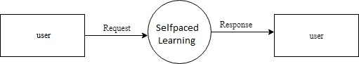

**Level 1 DFD shows Employee**

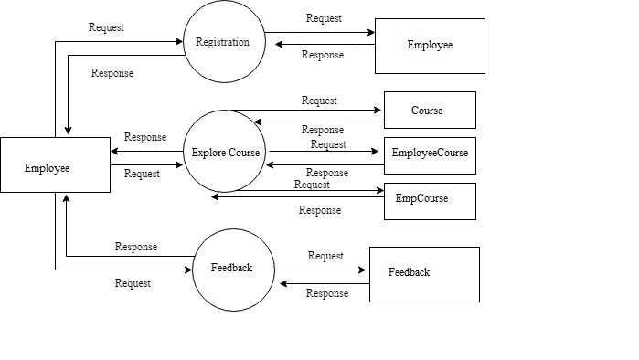

**Level 1 DFD shows Admin**

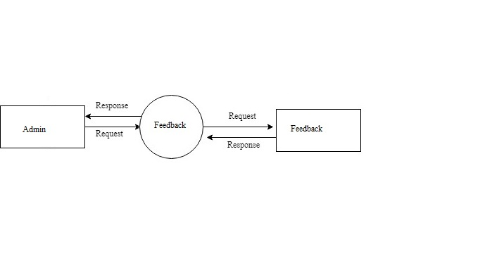

**Level 2 DFD shows Employee Details: Explore Course**

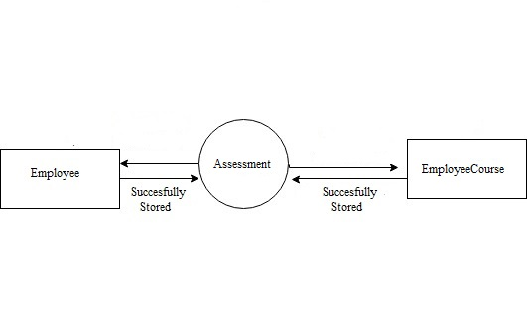

**Level 2 DFD shows Employee Details: Feedback**

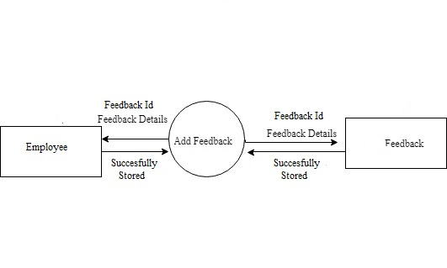

**Level 2 DFD shows Admin: Feedback**

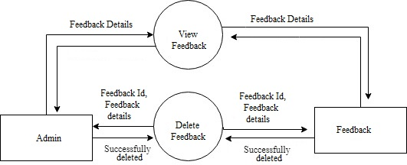

**3.3 UML DIAGRAM**

UML is a way of visualizing a software program using a collection of diagrams. The notation has evolved from the work of Grady Booch, James Rumbaugh, Ivar Jacobson and the Rational Software Corporation to be used for object-oriented design, but it has since been extended to cover a wider variety of software engineering projects. Today, UML is accepted by the Object Management Group(OMG) as the standard for modelling software development.

UML stands for Unified Modeling Language. UML 2.0 helps extend the original UML specification to cover a wider portion of software development efforts including agile practices. Improved integration between structural models like class diagrams and behavior models like activity diagrams. The original UML specified nine diagrams; UML

2.X brings that number up to 13. The four new diagrams are called: communication diagram, composite diagram, interaction overview diagram and timing diagram. It also renamed statechart diagrams to state machine diagrams , also known as state diagrams.

## Types of UML diagrams

The current UML standards call for 13 different types of diagrams: class, activity, object, use case, sequence, package, state, component, communication, composite structure, interaction overview, timing and deployment. These diagrams are organized into two distinct groups: structural diagrams and behavioral or interaction diagram.

## Structural UML diagrams

* Class diagram
* Package diagram
* Object diagram
* Component diagram
* Composite structure diagram
* Deployment diagram

## Behavioral UML diagrams

* Activity Diagram
* Sequence diagram
* Use case diagram
* State diagram
* Communication diagram
* Interaction overview diagram
* Timing diagram

## Usecase Diagram

To model a system the most important aspect is capture the dynamic behaviour. To modify a bit in details, dynamic behaviour of the system when it is running or operating. So only behaviour is not sufficient to model a system rather dynamic behaviour is more important than static behaviour. In UML there are five diagrams available to model dynamic nature and use case diagram is one of them. Now as we have to discuss that the use case diagram is dynamic in nature there should be some internal or external factors for making the interaction. These internal and external agents are known as actors. So use case diagram consists of actors, use case and their relationships. The diagram is used to model the system of an application. A single use case diagram captures a particular functionality of a system.

**Use case Diagram objects:**

* Actor
* Use case
* System
* Package

## Actor

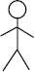Actor is a use case diagram in an entity that performs a role in one given system. This could be a person, organization or an external system usually drawn like skeleton.

**Fig1:Actor**

**Use case**

A use case represents a function or an action within the system. Its drawn as an oval and named with the function.

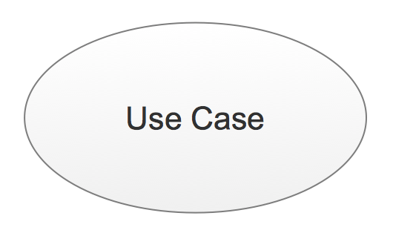

**Fig2:Use Case**

## System

System is used to define the scope of the use case and drawn as a rectangle. This is an optional element but useful when your visualizing large systems. For example you can create all the use cases and then use the system object to define the scope covered by your project. Or you can even use it to show the different areas covered in different releases.

## Fig3:System

## Package

Package is another optional element that is extremely useful in complex diagrams.

Similar to use class diagrams, packages are used to group together use cases.

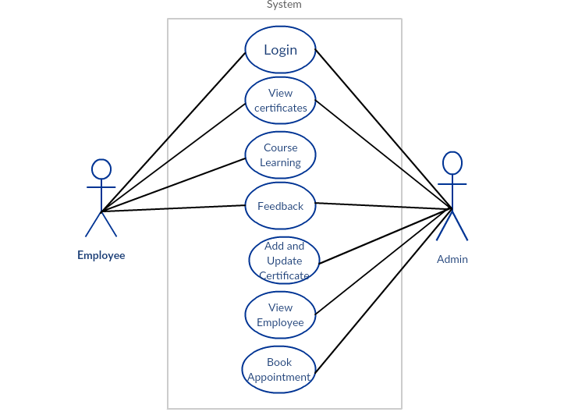

**Figure 4: Usecase Diagram**

* + 1. **Sequence Diagram**

UML sequence diagrams are used to represent or model the flow of messages, events and actions between the objects or components of a system. Time is represented in the vertical direction showing the sequence of interaction of the header elements. Sequence Diagrams are used primarily to design, document and validate the architec ture, interfaces and logic of the system by describing the sequence of actions that need to be performed to complete a task. UML sequence diagrams are useful design tools because they provide a dynamic view of the system behavior which can be difficult to extract from static diagrams or specifications.

Although UML sequence diagrams are typically used to describe object-oriented software systems, they are also extremely useful as system engineering tools to design system architectures in business process, as message sequence charts and call flows for telecoms or wireless system design, and for protocol stack design and analysis.

A sequence diagram is an interaction diagram that shows how objects operate with one another and in what order. It is a construct of a message sequence chart. A sequence diagram shows object interactions arranged in time sequence. It depicts the objects and classes involved in the scenario and the sequence of messages exchanged between the objects needed to carry out the functionality of the scenario. Sequence Diagrams are typically associated with use case realizations in the logical View of the system under development. Sequence diagrams are sometimes called event diagrams or event scenarios.

A sequence diagram shows, as parallel vertical lines (lifelines), different processes or objects that live simultaneously, and, as horizontal arrows, the messages exchanged between them, in the order in which they occur. This allows the specification of simple runtime scenarios in a graphical manner.

**3.4 SYSTEM DESIGN**

Design is the abstraction of a solution; it is a general description of the solution to a problem without the details. Design is view patterns seen in the analysis phase to be a pattern in a design phase. After design phase we can reduce the time required to cre- ate the implementation. The design is a solution, the transition of requirements in two ways of meeting them. The design will determine the success of the system. Based on the proposed system objectives, the major modules are identified and the operations to be carried out are determined. In the design phase of the system the user interaction screen, database tables ,inputs, outputs and screen are designed. The database tables are designed by using all the necessary fields in a compact manner. The redundancy and duplication of fields are avoided.

Systems design involves first logical design and the n physical construction of the system. After logical design, a detailed specification of the system, which describes the inputs, outputs, files are developed. During the design phase of system the following factors are considered.

The important of software design can be stated with a single word quality. Design is placed where quality is fostered in software development. Design is the only way whose requirements are actually translated into a finished software product or system.

* Data Floors:-The movement of data into, around and out of the system
* Data Source:-Temporary and permanent collections of data
* Processors:-Activities to accept, manipulate and deliver data and information
* Procedures:-Methods and routines to achieve the intended results

## Input Design

The input is the set of values that is provided by the user to the system. The input design must enable the user to provide the error free input to the system for efficient processing. The data is fed into the system using simple interactive xml pages. The pages have been supplied with messages so that user can enter data without facing any difficulty. The data is validated wherever it requires in the project

The main objectives of the input design are as follows:

* Produce effective method of input
* Achieve high level accuracy
* Ensure that the input is acceptable and understood by the user .

The different types of input data handled by the system are:

## External

They are the primary inputs to the system. The external input is what the user supplies to the system. The user can give different types of external inputs in this project such as registration details ,login details etc.

## Internal

When the external inputs are obtained from the user, these inputs are transferred to the system as messages. These messages are captured and handled as input for further processing.

In this project the input design is done with Android and PHP codes. The external in- puts are the data given to the system by the user. The neccessary external inputs are given to the system by Graphical User Interface(GUI)technology. The GUI system applied to this project enables the user to avoid error and confusion arises while entering the input.

## Output Design

The primary consideration in the design of all output is the information requirement and other objective of the users. It is the most important and direct source of information to the user. A major form of output is a hard copy. Print out should be designed around the output requirements of the user. Each output should be given a specific name or title. The output data is displayed on the visual display unit and output can be redirected to printers and or sorted in a file for later use.

## Database Design

Database is a design to manage large bodies of information. The management of data involves both the definition of structures for the storage information. In addition, the database system must provide for the safety of the information solved, despite system crashes or due to attempts at unauthorized access. For developing an efficient database we have to fulfil certain condition such as controlled redundancy

* Defining the data
* Inputting the data
* Locating the data
* Accessing the data
* Communicating the data
* Revising the data

**OBJECTIVES OF DATABASE** In the database design, several objectives are considered such as

* Control of data Integrity
* Ease of use
* Control of redundancy
* Control of security
* Data independence(Logical and physical)
* Data storage protection(Record level and Table level)
* System performance
* System functions
* System compatibility

For achieving the above mentioned criteria we have to make use various features that are available with the RDBMS by enforcing integrity constraints, we can ensure data integrity and reduce data inconsistency to a great extent. Recovery from failures can overcome using backup facilities. By using table level as well as row level locking facilities , we can avoid concurrent access normalize. Another important features of RDBMS is the logical and physical data independence. In addition to security mechanism provided by RDBMS, we have provided system password to near system

**NORMALIZATION:** Normalization is the term obtained from the Latin word NORMA which means that square used by the carpenter . Normalization is the process of simplifying the relationship between data elements in a record, through normalization a collection of data I a record structure is replaced by successive record structures that

are simpler and can be managed efficiently. While designing the database, we have to implement the concept of normalization to avoid data redundancy in the database. Normalization is carried out for four reasons.

* To structure the data so that any pertinent relationship between entities can be represented.
* To permit simple retrieval of data in response to query and reports required.
* To simplify data maintenance procedures such as insertion, deletion and updating.
* To reduce the need to be structure or reorganize data with new application requirements arise.

The major normalization strategies are

* First Normal Form
* Second Normal Form
* Third Normal Form
* Boyce/Codd Normal Form(BCNF)

**FIRST NORMAL FORM:** First Normal Form is achieved when all repeating groups in a record are removed, so that record is of fixed length. A repeating group, reoccurrence of a data item or group of data item within a record indicates another relation.

**SECOND NORMAL FORM:** Second Normal Form is achieved when a record is in first normal form and each item in the record is functionally depend on the primary key for identification. In other words, analyst seeks functional dependency. A data item is functionally dependent of its value is uniquely associated with a specific data item is functionally dependent of its value is uniquely associated with a specific item. To achieve second normal form every column in a table that is not dependent on the primary key of the record should be removed and used to form a separate relation.

**THIRD NORMAL FORM:** Third Normal Form is achieved when all transitive dependencies are removed from a record. That is, if A is functionally dependent on B and B is functionally dependent on C, then A is functionally dependent on C.

**BOYCE/CODD NORMAL FORM(BCNF):** BCNF is often used to distinguish the new 3NF from the old. An attribute possible composite is called as determinant. If other attributes are fully functionally determined this attribute(or on which some other attribute is fully functionally dependent on this attribute).A table is in BCNF , if every determinant is a candidate key. To achieve a table is in BCNF, remove fields which are fully functionally dependent on a determinant, which is not act as a candidate key.

|  |  |  |  |
| --- | --- | --- | --- |
| **FIELDS** | **DATA TYPE** | **CONSTRAINT** | **DESCRIPTION** |
| empid | Number(3) | Primary key | It is used to store the unique id of employee |
| name | Varchar(200) | Not  Null | Name of Employee |
| dob | Date |  | Date of birth |
| password | Varchar(500) | Not  Null | Password |
| email | Varchar(200) | Not  Null | Email id |
| ranking | Number(2) |  | Ranking |
| badges | Number(2) |  | Badges |
| phone_number | Int | Not  Null | Phone number |

**Table: Employee**

|  |  |  |  |
| --- | --- | --- | --- |
| **FIELDS** | **DATA TYPE** | **CONSTRAINT** | **DESCRIPTION** |
| courseid | Number(4) | Primary key | It is used to store the unique id of course |
| no_of_enroll | Number(2) | Not  Null | Number of enrollment |
| course_Name | Varchar(25) |  | Name of the course |
| description | Varchar(40) | Not  Null | Description about the course |
| duration | Number(3) | Not  Null | Duration of the course |

**Table: Course**

**Table: Feedback**

|  |  |  |  |
| --- | --- | --- | --- |
| **FIELDS** | **DATA TYPE** | **CONSTRAINT** | **DESCRIPTION** |
| empid | Number(3) | Foreign key  Not Null | It is used to store the unique id of employee |
| courseid | Number(4) | Foreign key  Not Null | It is used to store the unique id of course |
| feedbackid | Number(5) | Primary key | It is used to store the unique id of feedback |
| Review | Varchar(50) | Not  Null | Review |

**Table: EmployeeCourse**

|  |  |  |  |
| --- | --- | --- | --- |
| **FIELDS** | **DATA TYPE** | **CONSTRAINT** | **DESCRIPTION** |
| empcouid | Number(4) | Primary key | It is used to store the unique id of employee courses |
| courseid | Number(4) | Foreign Key | It is used to store the unique id of course |
| empid | Number(3) | Foreign Key | It is used to store the unique id of employee |
| status | Varchar(10) |  | Status |
| trail | Number(3) |  | Number of trials |
| max_score | Number(5,2) |  | Maximum score |

**Table: EmpCourse**

|  |  |  |  |
| --- | --- | --- | --- |
| **FIELDS** | **DATA TYPE** | **CONSTRAINT** | **DESCRIPTION** |
| empid | Number(3) | Foreign key  Not Null | It is used to store the unique id of employee |
| courseid | Number(4) | Foreign key  Not Null | It is used to store the unique id of course |

**3.5 TOOLS AND APPLICATION**

**3.5.1 ANGULAR**

UI designing is one of the most crucial parts of any application. UI is where the user interacts with any application, hence it has to be designed in a user-friendly manner. Many frameworks have come into existence for the same. Angular is one such very powerful framework for building client applications using any scripting language such as JS or TypeScript. The most preferred scripting language for Angular is TypeScript which can again be compiled to JavaScript. Any UI designer would appreciate Angular if he already knows any traditional approaches as this framework helps us in designing application with better performance and maintainability for both mobiles and desktops.

Angular is a platform that makes it easy to build applications with the web. Angular combines declarative templates, dependency injection, end to end tooling, and integrated best practices to solve development challenges. Angular empowers developers to build applications that live on the web, mobile, or the desktop.

**Angular and TypeScript**

Angular is one of the most powerful client-side U.I. framework which can be used to develop **complex**, **customizable**, **modern**, **responsive** and **userfriendly** web applications. Some such applications are PayPal, Netflix, Weather etc.Angular is a single framework which addresses concernsof bothmobileanddesktop application.The Angular framework has chosen a **new statically-typed**, **client-side scripting** language called TypeScript, which beautifully works around most if not all such pitfalls of JavaScript. The Angular team recommends the usage of TypeScript for Angular applications. Hence, to start building Angular applications, we would need to learn to write simple TypeScriptcode first and then look at the Angular application design.

**Pitfalls of JavaScript**

JavaScript is the language used for client side scripting. We can do client side validations, DOM manipulation, Ajax calls etc using JavaScript. We can also use JavaScript frameworks for writing complex business logic which runs on the client side.

As the complexity of the JavaScript code increases, it gradually becomes difficult in coding and maintaining. This is because of the following pitfalls of JavaScript language.

**Dynamic Typing**: Dynamic typing means deciding the data type of the variable dynamically at runtime which results in recompilation every time the code is executed.

**Interpreted Language**: Interpreted Language is a language in which the code instructions are executed directly without prior compilation to machine-language instructions hence we will not get to know the errors until the code is executed.

**Minimal Object Oriented support**: JS supports minimal Object Oriented concepts like classes, encapsulation, inheritance which helps in readability and reusability of the code.

**Minimal IDE support**: Integrated development environment (IDE) is a software application that provides all necessary options like code refactoring, intellisense support, Debugging support to software programmers for software development which is least supported in JS.

Albeit all these shortcomings, we are still dependent on JS as it is the most common scripting language for browsers. But as programmers, we might be in luck.

The solution can be to choose a language which is rich in features and the code can be converted to JavaScript for browsers. This process of converting code written in one language into another language is generally called Transpilation.

TypeScript is one such language whose code can be transpiled to JavaScript. This conversion is required because browser cannot understand TypeScript code.

**What is TypeScript**

TypeScript is a typed superset of JavaScript that transpiles to JavaScript.

* TypeScript makes the development of JavaScript nearer to a more traditional object oriented experience.
* TypeScript is based on [ECMAScript](http://www.ecma-international.org/) 7 proposals.
* Apart from the EcmaScript specification, TypeScript has its own features as well.
* Any valid JavaScript is TypeScript.

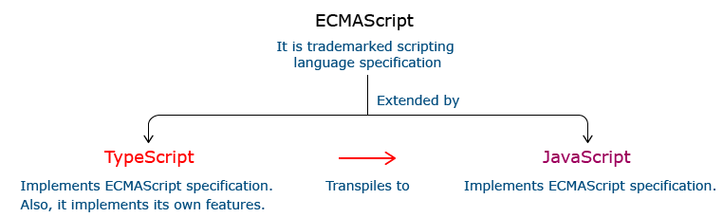

**Relationship Between TypeScript and JavaScript**

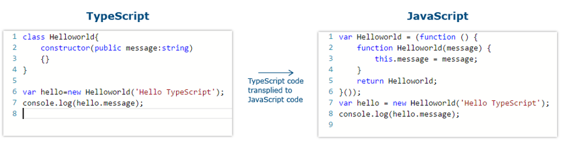

**I**n the code given above, the TypeScript class HelloWorld is converted to a self invoking function in JavaScript when transpiled.

**Features Of TypeScript:**

**Static Typing**: It adds static typing to JavaScript, due to which the readability of the code improves and also helps in finding more early compilation errors than the runtime errors.

**Modules support:**TypeScript provides an option to create modules so that we can modularize the code for easy maintenance. Modules also help in making the application scalable.

**Object Oriented Programming:**TypeScript supports object oriented programming features such as classes, encapsulation, interface, inheritance and so on which help in creating highly structured and reusable code.

**Open Source:**TypeScript is open source. The source code of TypeScript can be downloaded from github.

**Cross Platform: It works across platforms.**

**Tooling Support:**TypeScript works extremely well with Sublime Text, Eclipse, and almost all major IDEs as compared to JavaScript

**Angular 6**

The Angular 6 app folder has the following folder structure −

* **e2e** − end to end test folder. Mainly e2e is used for integration testing and helps ensure the application works fine.
* **node_modules** − The npm package installed is node_modules. You can open the folder and see the packages available.
* **src** − This folder is where we will work on the project using Angular 4.

The Angular 6 app folder has the following file structure −

* .**angular-cli.json** − It basically holds the project name, version of cli, etc.
* **.editorconfig** − This is the config file for the editor.
* **.gitignore** − A .gitignore file should be committed into the repository, in order to share the ignore rules with any other users that clone the repository.
* **karma.conf.js** − This is used for unit testing via the protractor. All the information required for the project is provided in karma.conf.js file.
* **package.json** − The package.json file tells which libraries will be installed into node_modules when you run npm install.

**In case you need to add more libraries, you can add those over here and run the npm install command.**

* **protractor.conf.js −** This is the testing configuration required for the application.
* **tsconfig.json −** This basically contains the compiler options required during compilation.
* **tslint.json −** This is the config file with rules to be considered while compiling**.**

The src folder is the main folder, which internally has a different file structure.

app

It contains the files described below. These files are installed by angular-cli by default.

* **app.module.ts −** If you open the file, you will see that the code has reference to different libraries, which are imported. Angular-cli has used these default libraries for the import - angular/core, platform-browser. The names itself explain the usage of the libraries.

They are imported and saved into variables such as declarations, imports, providers, and bootstrap.

**declarations** − In declarations, the reference to the components is stored. The Appcomponent is the default component that is created whenever a new project is initiated. We will learn about creating new components in a different section.

**imports** − This will have the modules imported as shown above. At present, BrowserModule is part of the imports which is imported from @angular/platform-browser.

**providers** − This will have reference to the services created. The service will be discussed in a subsequent chapter.

**bootstrap** − This has reference to the default component created, i.e., AppComponent.

* **app.component.css** − You can write your css structure over here. Right now, we have added the background color to the div as shown below.
* **app.component.html** − The html code will be available in this file.

This is the default html code currently available with the project creation.

* **app.component.spec.ts** − These are automatically generated files which contain unit tests for source component.
* **app.component.ts** − The class for the component is defined over here. You can do the processing of the html structure in the .ts file. The processing will include activities such as connecting to the database, interacting with other components, routing, services, etc.

**Assets**

You can save your images, js files in this folder.

**Environment**

This folder has the details for the production or the dev environment. The folder contains two files.

* environment.prod.ts
* environment.ts

Both the files have details of whether the final file should be compiled in the production environment or the dev environment.

To install Angular 6, we require the following −

* Nodejs
* Npm
* Angular CLI
* IDE for writing your code

Nodejs has to be greater than 8.11 and npm has to be greater than 5.6.

**Nodejs**

To check if nodejs is installed on your system, type node -v in the terminal. This will help you see the version of nodejs currently installed on your system.

**C:\>node -v**

**v8.11.3**

If it does not print anything, install nodejs on your system. To install nodejs, go the homepage https://nodejs.org/en/download/ of nodejs and install the package based on your OS.

The homepage of nodejs will look like the following −

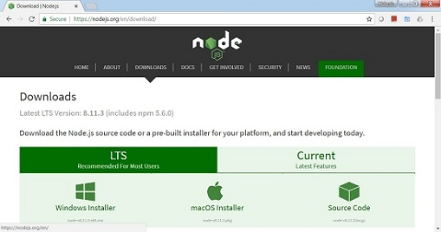

**NodeJS Homepage**

Based on your OS, install the required package. Once nodejs is installed, npm will also get installed along with it. To check if npm is installed or not, type npm -v in the terminal. It should display the version of the npm.

**C:\>npm -v**

**5.6.0**

Angular 4 installations are very simple with the help of angular CLI. Visit the homepage https://cli.angular.io/ of angular to get the reference of the command.

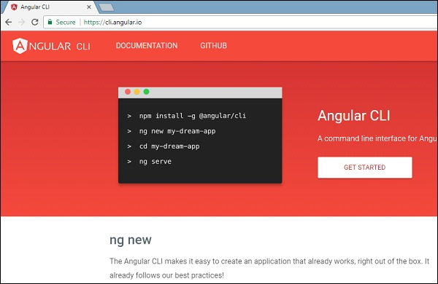

Type npm install -g @angular/cli, to install angular cli on your system.

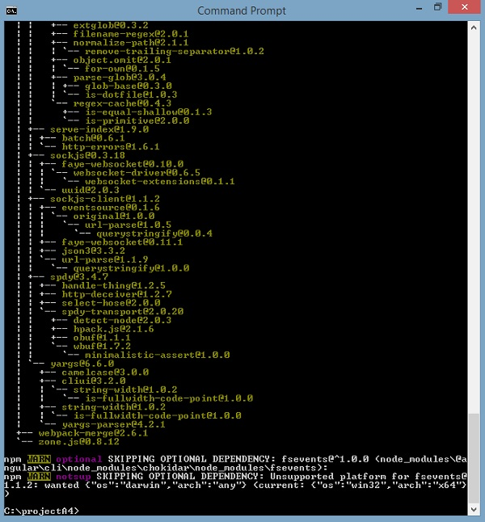

**Install Angular CLI**

You will get the above installation in your terminal, once Angular CLI is installed. You can use any IDE of your choice, i.e., WebStorm, Atom, Visual Studio Code, etc.

AngularJS is based on the model view controller, whereas Angular 4 is based on the components structure. Angular 6 works on the same structure as Angular4 but is faster when compared to Angular4.

Angular6 uses TypeScript 2.9 version whereas Angular 4 uses TypeScript version 2.2. This brings a lot of difference in the performance.

To install Angular 6, the Angular team came up with Angular CLI which eases the installation. You need to run through a few commands to install Angular 6.

.

**3.5.2 VISUAL STUDIO CODE IDE**

Visual Studio Code is a source-code editor developed by Microsoft for Windows, Linux and macOS. It includes support for debugging, embedded Git control and GitHub, syntax highlighting, intelligent code completion, snippets, and code refactoring. It is highly customizable, allowing users to change the theme, keyboard shortcuts, preferences, and install extensions that add additional functionality. The source code is free and open source and released under the permissive MIT License. The compiled binaries are freeware and free for private or commercial use.

Visual Studio Code is based on Electron, a framework which is used to deploy Node.js applications for the desktop running on the Blink layout engine. Although it uses the Electron framework, the software does not use Atom and instead employs the same editor component (codenamed "Monaco") used in Azure DevOps (formerly called Visual Studio Online and Visual Studio Team Services).

Typescript code can be written using several IDEs such as - Eclipse IDE, NetBeans IDE, Visual Studio Code IDE etc. We are prefer using Visual Studio Code IDE as it is a lightweight cross-platform editor which comes with built-in TypeScript support.

Typescript code is written in Visual Studio Code IDE in the following way:

**Step 1:**Create a folder on your desktop. This folder will be used as a work-space for Visual Studio Code. Let us name it **TypeScript_WorkSpace.**

**Step 2:** Create a folder and name it as **Demo**, inside the previously created folder. This folder will be used as a project folder.

**Step 3:**Launch Visual Studio Code IDE. Once launched, close the welcome page. We should get a screen similar to the one shown below.

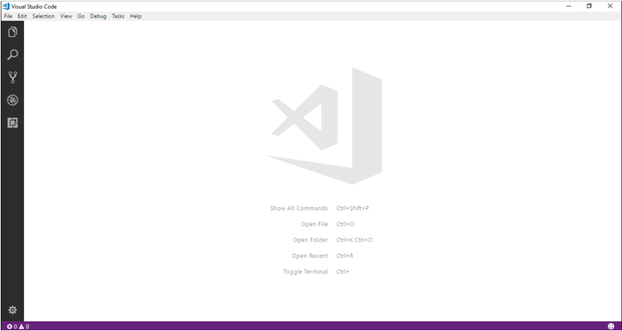

**Step 4:**Next step is to select a workspace. From the **File** menu, select **OpenFolder,** browse for the TypeScript_Demos folder and select it.

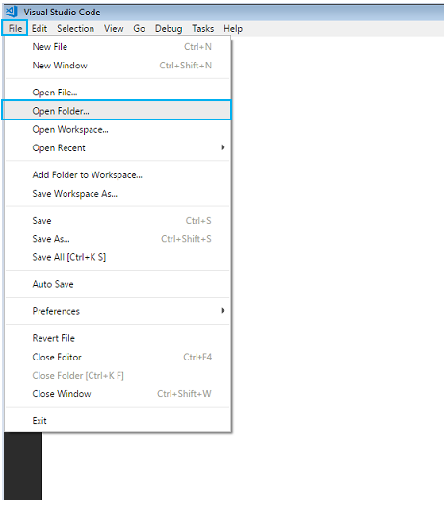

**Step 5:**The IDE will restart and the folder will be selected as work-space. We will also have the **TS_Demo** project folder as shown below.

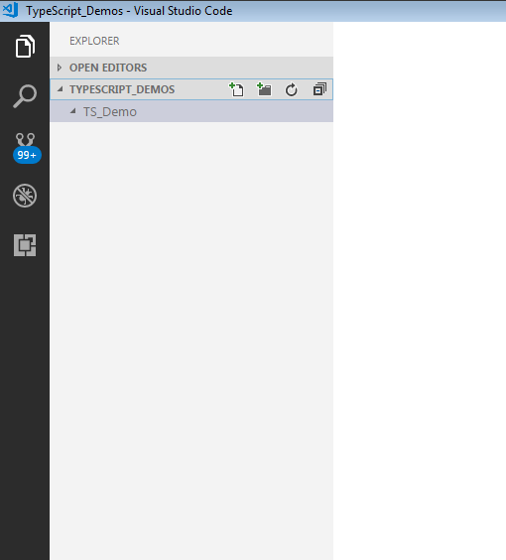

**Step 6:** Let us create a typescript file. Create a file named **firstApp.ts** in the project folder.

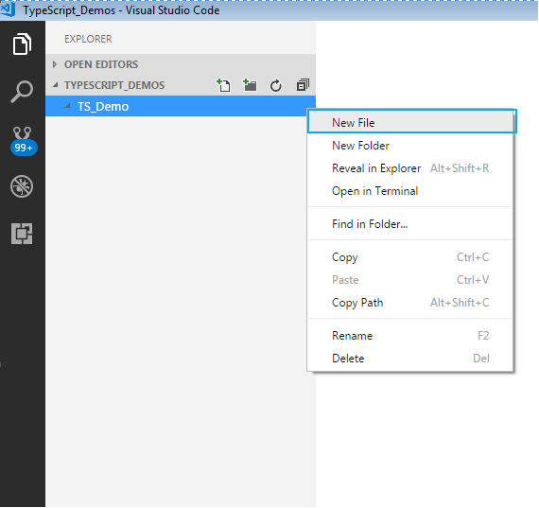

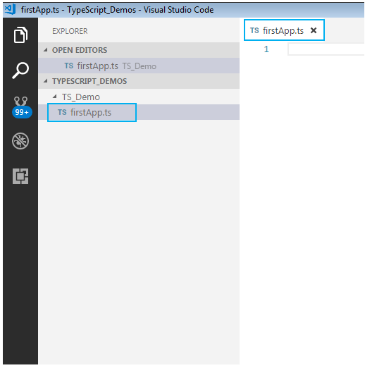

To start with the first application in TypeScript, in already created firstApp.ts file, give a console.log

statement and save it.

Here is how to do this:

**Step 7:** We shall print a welcome message when we run the above file. To do so, let us code as shown

**console.log("Hello! Welcome to TypeScript");**

**Step 8:**

To execute the code, we will have to navigate to the project folder. For this, we will use windows command prompt through VSCode. Open the command prompt by following step:

* Navigate to View tab in VSCode.
* Select Integrated Terminal.

Alternatively, you can use the shortcut, **ctrl+`**, to open the command prompt. We will get the command prompt as shown below.

From the command prompt navigate to the folder in which the ts file resides and **transpile**the **.ts** file using the **tsc**command as follows:

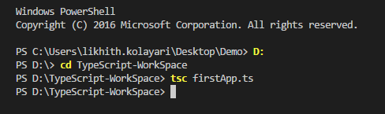

**Step 9:** Run the transpiled **.js** file using  **node**  command . On execution of the code, the output is

displayed on the console as shown.

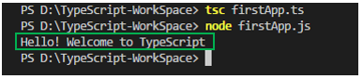

**3.4.2 ORACLE**

The Oracle Server is a relational database management system that provides an open, comprehensive, and integrated approach to information management. An Oracle Server consists of an Oracle database and an Oracle instance. The following sections describe the relationship between the database and the instance.

### Structured Query Language (SQL)

SQL (pronounced SEQUEL) is the programming language that defines and manipulates the database. SQL databases are relational databases; this means simply that data is stored in a set of simple relations. A database can have one or more tables. And each table has columns and rows. A table that has an employee database, for example, might have a column called employee number and each row in that column would be an employee's employee number.

You can define and manipulate data in a table with SQL commands. You use data definition language (DDL) commands to set up the data. DDL commands include commands to creating and altering databases and tables.

You can update, delete, or retrieve data in a table with data manipulation commands (DML). DML commands include commands to alter and fetch dat. The most common SQL command is the SELECT command, which allows you to retrieve data from the database.

In addition to SQL commands, the Oracle Server has a procedural language called PL/SQL. PL/SQL enables the programmer to program SQL statements. It allows you to control the flow of a SQL program, to use variables, and to write error-handling procedures.

### **Database Structure**

An Oracle database has both a physical and a logical structure. Because the physical and logical server structure are separate, the physical storage of data can be managed without affecting the access to logical storage structures.

**Physical Database Structure**An Oracle database's physical structure is determined by the operating system files that constitute the database. Each Oracle database is made of three types of files: one or more datafiles, two or more redo log files, and one or more control files. The files of an Oracle database provide the actual physical storage for database information.

**Logical Database Structure** An Oracle database's logical structure is determined by

* one or more tablespaces. (A tablespace is a logical area of storage explained later in this chapter.)
* the database's schema objects. A *schema* is a collection of objects. *Schema objects* are the logical structures that directly refer to the database's data. Schema objects include such structures as tables, views, sequences, stored procedures, synonyms, indexes, clusters, and database links.

The logical storage structures, including tablespaces, segments, and extents, dictate how the physical space of a database is used. The schema objects and the relationships among them form the relational design of a database.

### **An Oracle Instance**

Every time a database is started, a system global area (SGA) is allocated and Oracle background processes are started. The system global area is a an area of memory used for database information shared by the database users. The combination of the background processes and memory buffers is called an Oracle *instance.*

An Oracle instance has two types of processes: user processes and Oracle processes.

A user process executes the code of an application program (such as an Oracle Forms application) or an Oracle Tool (such as Server Manager).

Oracle processes are server processes that perform work for user processes and background processes that perform maintenance work for the Oracle Server.

**3.5.3 ECLIPSE IDE**

Eclipse is a free, [Java](https://www.theserverside.com/definition/Java)-based development platform known for its [plug-ins](https://whatis.techtarget.com/definition/plug-in) that allow developers to develop and test code written in other programming languages. Eclipse is released under the terms of the Eclipse PublicLicense.  
Eclipse got its start in 2001 when IBM donated three million lines of code from its Java tools to develop an [open source](https://whatis.techtarget.com/definition/open-source) integrated development environment ([IDE](https://searchstorage.techtarget.com/definition/IDE)). The IDE was initially overseen by a consortium of software vendors seeking to create and foster a new community that would complement [Apache](https://whatis.techtarget.com/definition/Apache)’s open source community. Rumor has it that the platform’s name was derived from a secondary goal, which was to eclipse Microsoft’s popular IDE, [Visual Studio](https://searchwindevelopment.techtarget.com/definition/Visual-Studio-NET).



Today, Eclipse is managed by the Eclipse Foundation, a not-for-profit corporation whose strategic members include CA Technologies, IBM, Oracle and [SAP](https://searchsap.techtarget.com/definition/SAP). The foundation, which was created in 2004, supports Eclipse projects with a well-defined development process that values quality, application programming interface ([API](https://searchmicroservices.techtarget.com/definition/application-program-interface-API)) stability and consistent release schedules. The foundation provides [infrastructure](https://searchdatacenter.techtarget.com/definition/infrastructure) and [intellectual property](https://whatis.techtarget.com/definition/intellectual-property-IP) (IP) management services to the Eclipse community and helps community members market and promote commercial software products that are based on Eclipse.

In 2016, Microsoft announced it would join the Eclipse Foundation and support the integration of Visual Studio by giving Eclipse developers full access to Visual Studio Team services. Oracle donated the Hudson continuous integration server it inherited from Sun Microsystems to Eclipse in 2011 and is expected to donate the Java 2 Platform, Enterprise Edition (Java EE) to Eclipse in the near future.

**CHAPTER 4**

**SYSTEM TESTING**

Software testing is an integral part of to ensure software quality, some software organizations are reluctant to include testing in their software cycle, because they are afraid of the high cost associated with the software testing .There are several factors that at- tribute the cost of software testing. Creating and maintaining large number of test cases is a time consuming process. Furthermore, it requires skilled and experienced testers to develop great quality test cases.

Even with the wide availability of automation tools for testing, the degree of automa- tion mostly remains at the automated test script level and generally significant amount of human intervention is required in testing. In addition data collected, as testing is conducted provides a good indication of software quality as a while. The debugging process is the most unpredictable part of testing process. Testing begins at the module level and work towards the integration of entire computer based system. No testing is completed without verification and validation part.

The goal of verification and validation activities are to access and improve the qual- ity of work products generated during the development and modification of the soft- ware. Testing plays a vital role in determining the reliability and efficiency of the software and hence is very important stage in software development. Tests are to be conducted on the software to evaluate its performance under a number of conditions. Ideally, it should do so at the level of each module and also when all of them are inte- grated to form the completed system.

In the project ”E-Medication Reminder App And Healthcare system” the testing has been successfully handled with the modules. The test data was given to each and every module in all respect and got the desired output. Each module that has been tested is found working properly.

# UNIT TESTING

Here we test each module individually and integrated the overall system. Unit testing focuses verification efforts even in the smallest unit of software design in each module. This is known as ”module testing”. The modules of this project are tested separately. This testing is carried out in the programming style itself. In this testing each module is focused to work satisfactorily as regard to expected output from the module. There are some validation checks for the fields. Unit testing gives stress on the modules of the project independently of one another, to find errors. Different modules are tested against the specifications produced during the design of the modules. Unit testing is done to test the working of individual modules with test servers. Program unit is usu- ally small enough that the programmer who developed it can test it in a great detail. Unit testing focuses first on that the modules to locate errors. These error are verified and corrected and so that the unit perfectly fits to the project.

# INTEGRATION TESTING

Data can be lost across an interface, one module can have an adverse effect on the other sub-functions, when combined they may not perform the desired functions. Integrated testing is the systematic testing to uncover the errors within the interface. This testing is done with simple data and the developed system has run successfully with this simple data. The need for integrated system is to find the overall system performance. The Modules of this project are connected and tested. After splitting the programs into units, the units were tested together to see the defects between each module and function. It is testing to one or more modules or functions together with the intent of finding interface defects between the modules or functions. Testing completed at as part of unit or functional testing, integration testing can involve putting together of groups of modules and functions with the goal of completing and verifying meets the system requirements.

# SYSTEM TESTING

System testing focuses on testing the system as a whole. System Testing is a crucial step in Quality Management Process. In the Software Development Life Cycle, System Test

ing is the first level where the System is tested as a whole. The System is tested to verify whether it meets the functional and technical requirements. The application/System is tested in an environment that closely resembles the production environment where the application will be finally deployed. The perquisites for System Testing are:-

* All the components should have been successfully Unit Tested.
* All the components should have been successfully integrated.

Testing should be completed in an environment closely resembling the production environment. When necessary iterations of System Testing are done in multiple environments.

# USER ACCEPTANCE TESTING

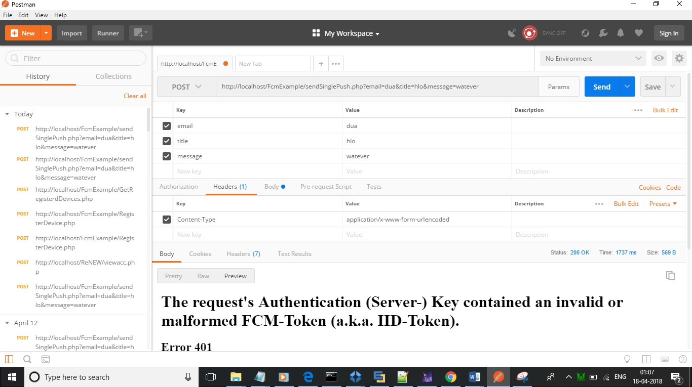The system was tested by a small client community to see if the program met the requirements defined the analysis stage. It was fond to be satisfactory. In this phase, the system is fully tested by the client community against the requirements defined in the analysis and design stages, corrections are made as required, and the production system is built. User acceptance of the system is key factor for success of the system.

Figure 4.1: Test case using POSTMAN

**CHAPTER 5**

**SYSTEM IMPLEMENTATION**

The implementation is one phase of software development. Implementation is that stage in the project where theoretical design is turned into working system. Implementation involves placing the complete and tested software system into actual work environment. Implementation is concerned with translating design specification with source code. The primary goal of implementation is to write the source code to its specification that can be achieved by making the source code clear and straight forward as possible. Implementation means the process of converting a new or revised system de- sign into operational one. The three types of implementation are : - implementation of a computerized system to replace a manual system, implementation of a new system to replace existing one and implementation of a modified system to replace an existing one.

The implementation is the final stage and it is an important phase. It involves the individual programming : system testing, user training , and the operational running of developed proposed system that constitute the application subsystem. The implementation phase of the software development is concerned with translating design specification in the source code. The user tests the developed system and the changes are according to the needs. Before implementation, several tests have been conducted to ensure no errors encountered during the operation. The implementation phase ends with an evaluation of the system after placing it into operation of time. The validity and proper functionality of all the modules of the developed application is assured during the process of implementation. Implementation is the process of assuring that the information system is operational and then allowing user to take over its operation for use and evaluation. Implementation is the stage in the project where the theoretical design is turned into a working system. The implementation phase constructs, installs and operated the new system. The most crucial stage in achieving a new successful system is that it works effectively and efficiently.

# CHAPTER 6 CONCLUSION

Selfpaced Learning is an online website which is mainly focuses on employees in Infosys DC’s. The ETA heads need a system that can automatically record and store course-wise session recording which can be referred to by any employees at any point of time. Every online course should be supplemented with the corresponding question bank. After completing a course, the learner must attempt the test in order to achieve a badge -Completed Course. Certification is also one of the best advantage of the proposed system. After completing the course employee can request to generate certificate and employee can download the certificate.

The main focus on overall performance of the system. Selfpaced learning provide good interface so that employees can friendly interact with the website . The main of the website is to improve the knowledge of the employees.

# CHAPTER 7

# REFERENCES

* + - Bipin .C.Desai,An Introduction To Database System published by West.Publishing Company in 1990.
    - Somer Vilie, Software Engineering published by Pearson in March13,2010.
    - Sudarshan Silberschatz, Database System Concepts published by MCGraw- Hill Publication 2013.
    - Henry F.Korth and Abraham Silberschatz,Database System Concepts published by MCGraw-Hill in 1986.
    - <https://www.seleniumhq.org/docs/01_introducing_selenium.jsp>
    - https://medium.freecodecamp.org/angular-what-is-the-new-briefly-e6837348dd3a

# CHAPTER 8

# APPENDIX

**Home:**

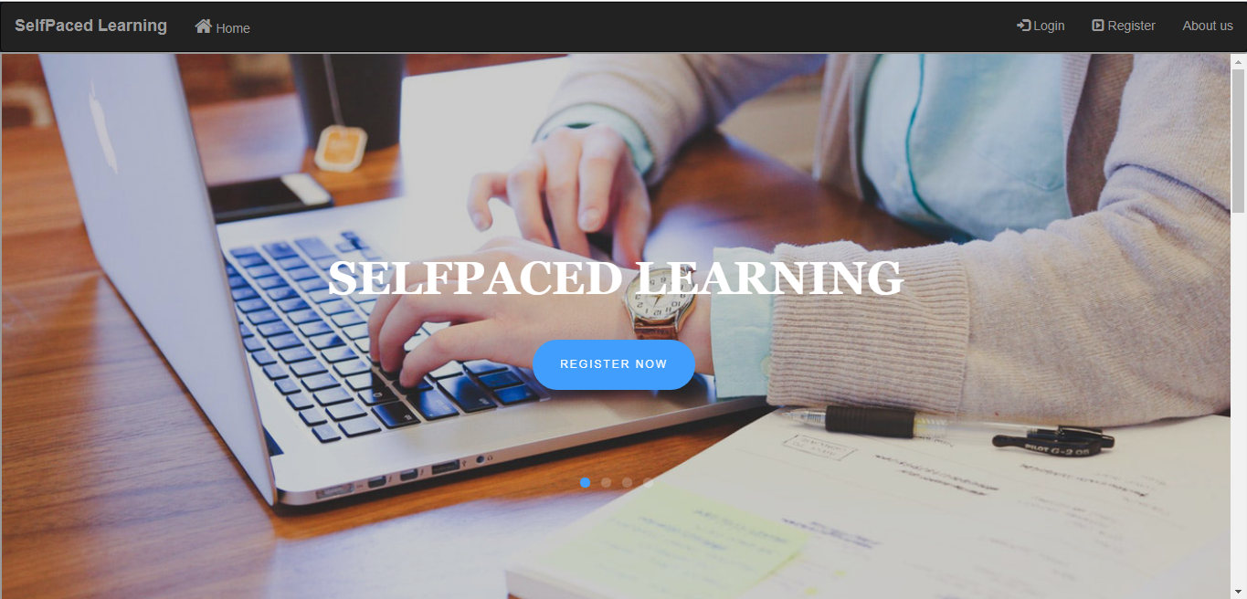

**Login**:

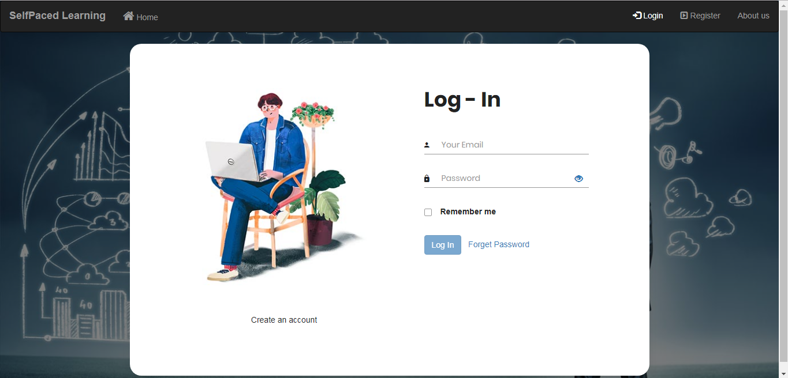

**Register:**

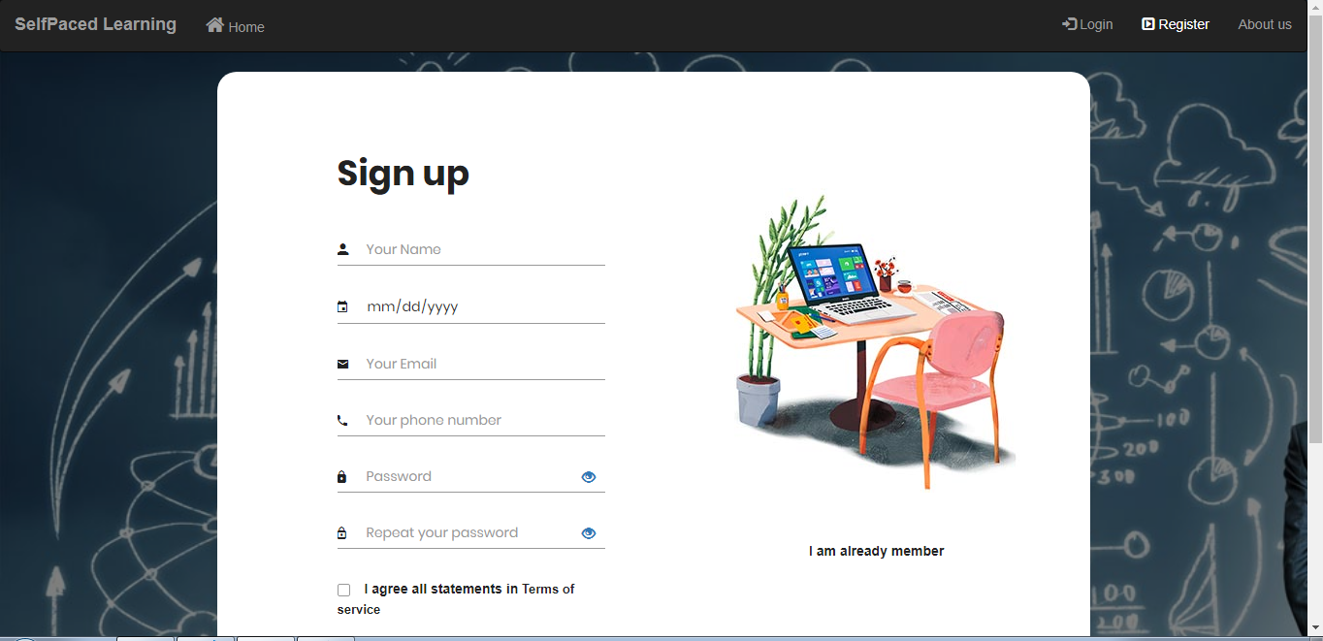

**About Us:**

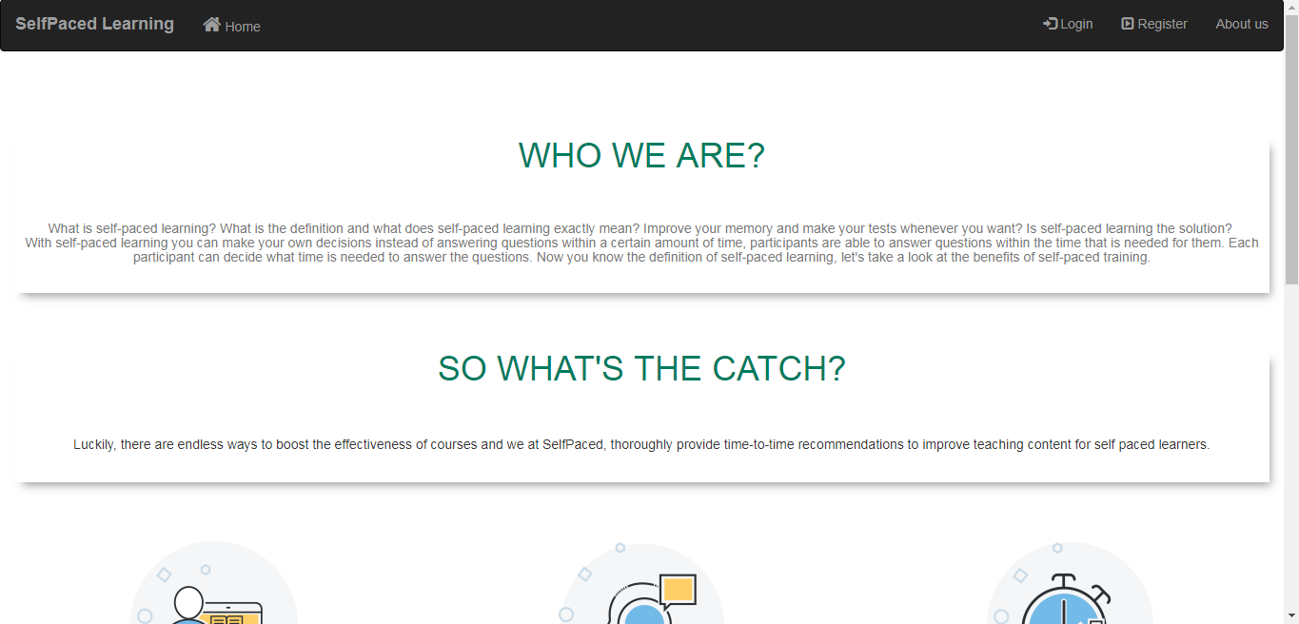

**Employee Login:**

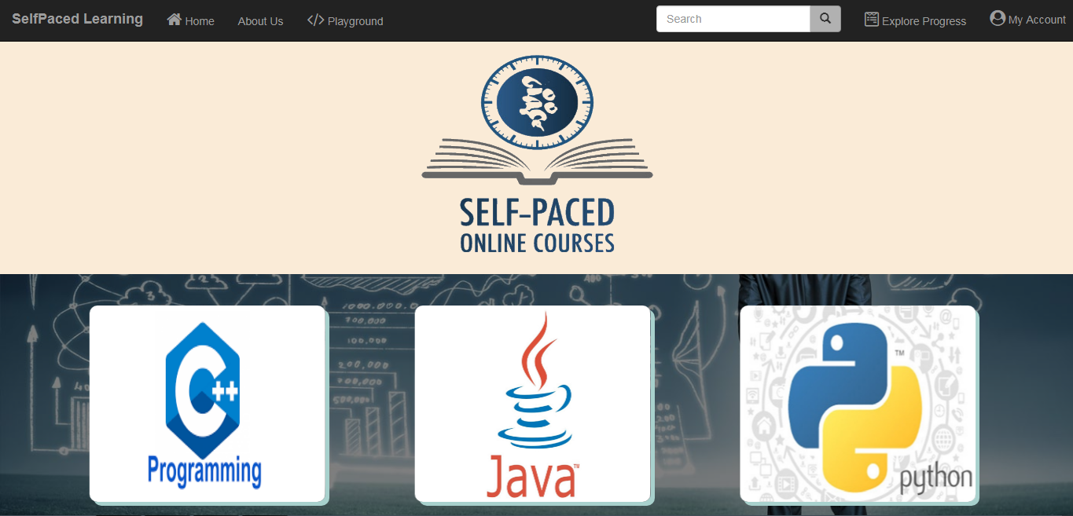

**Employee Profile:**

**Explore Course:**

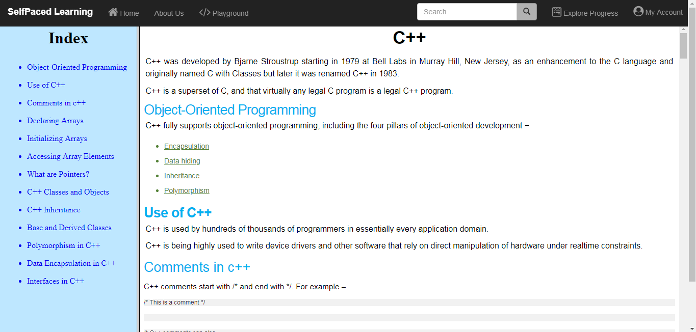

**Test:**

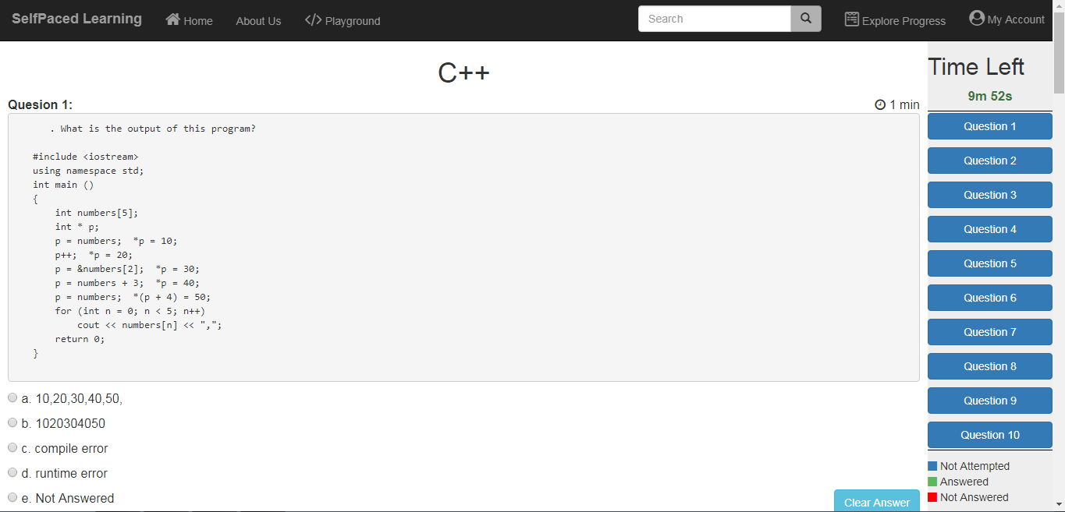

**Submitting Test:**

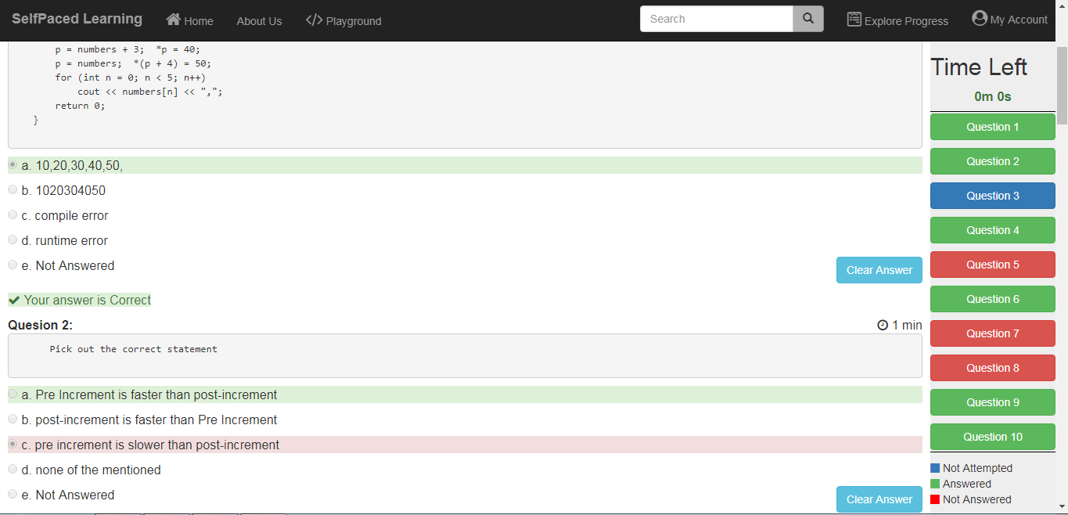

**Test Result:**

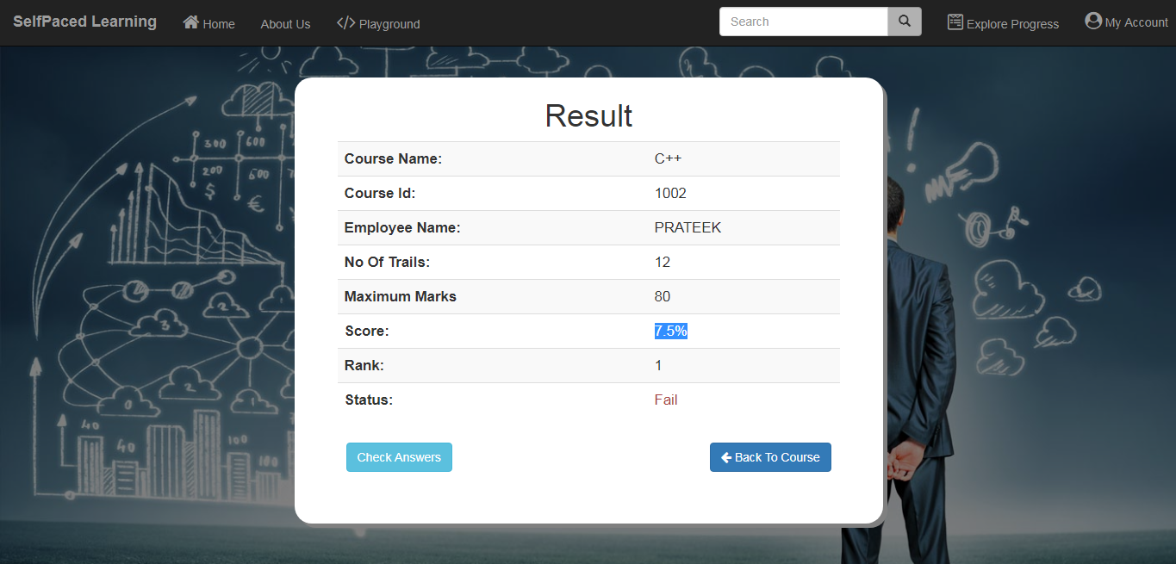

**Coding Playground:**

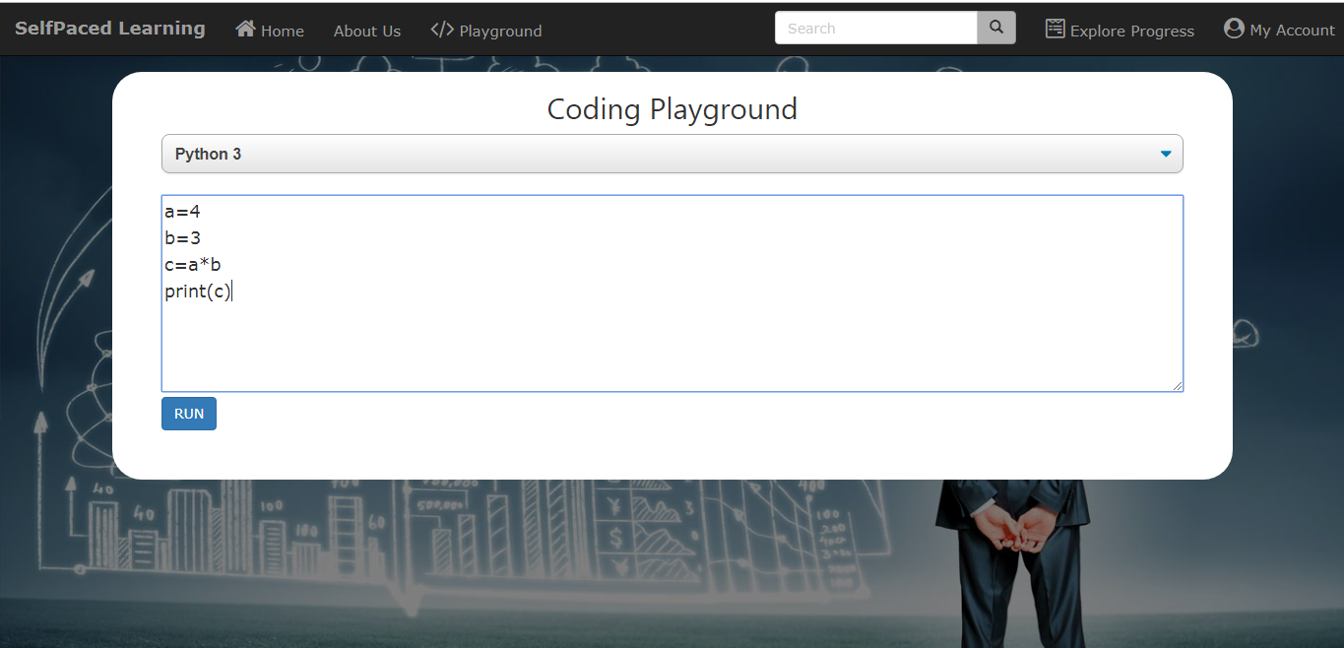

**Coding Playground Result:**

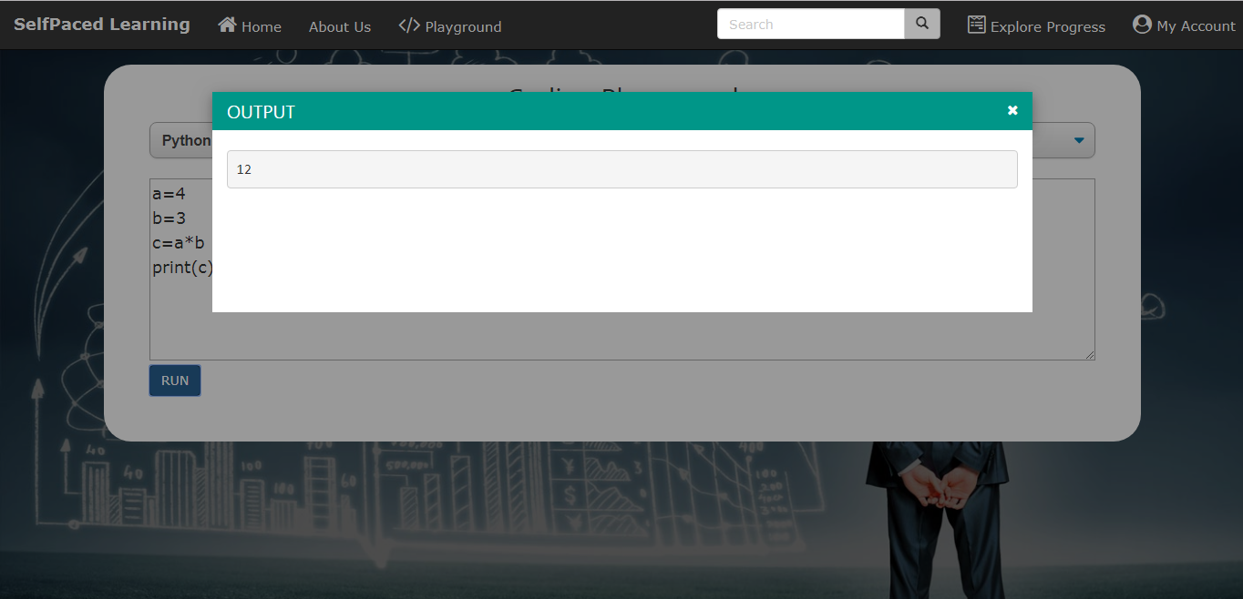

**Certificate Details:**

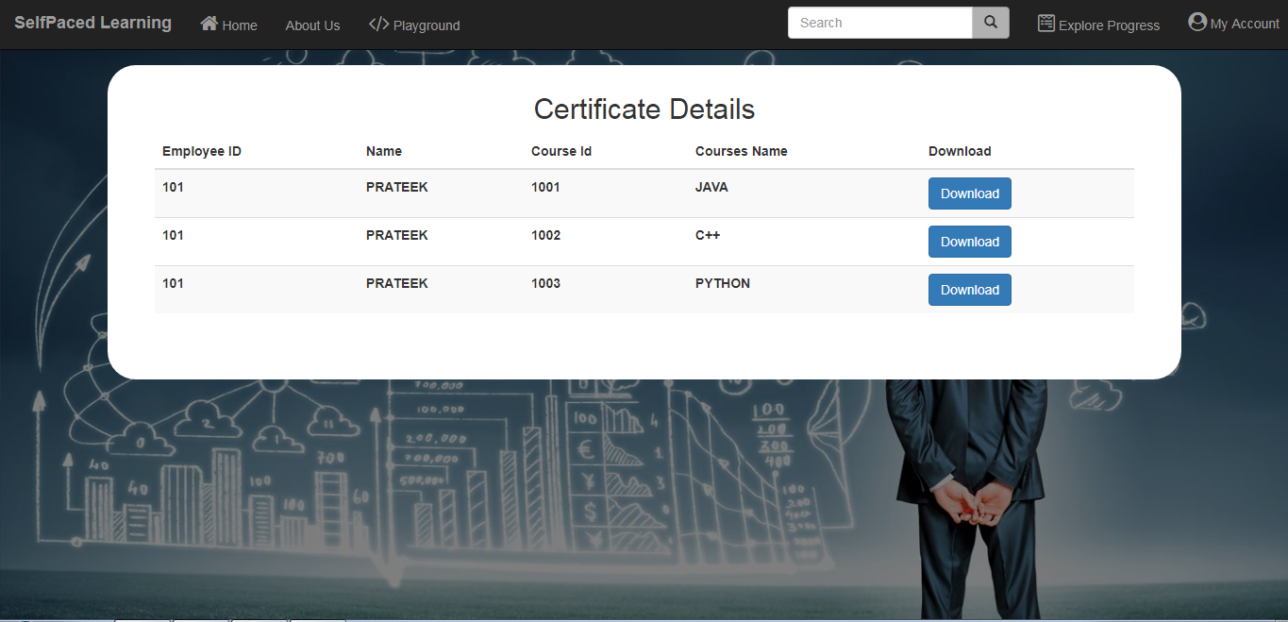

**Student Details:**

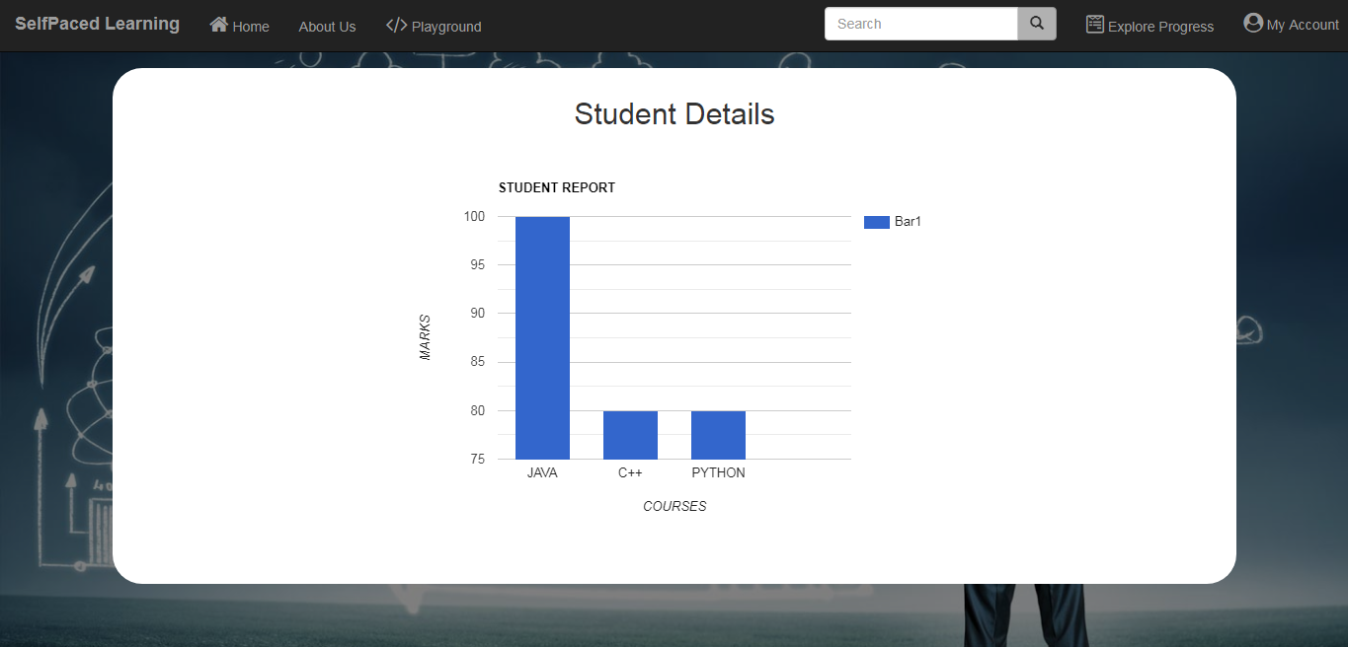

**Change Password:**

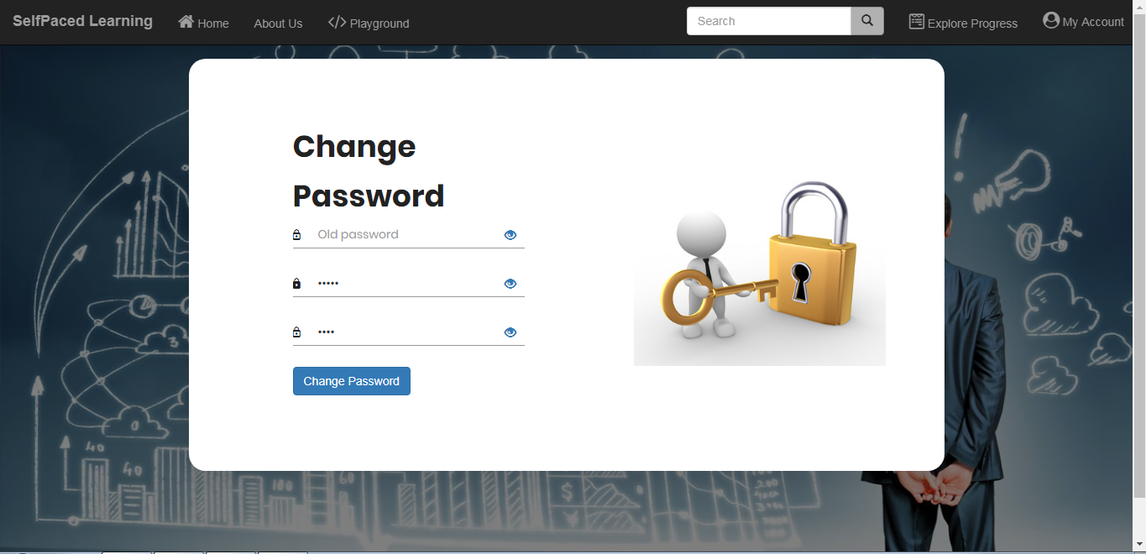

**Update Profile:**

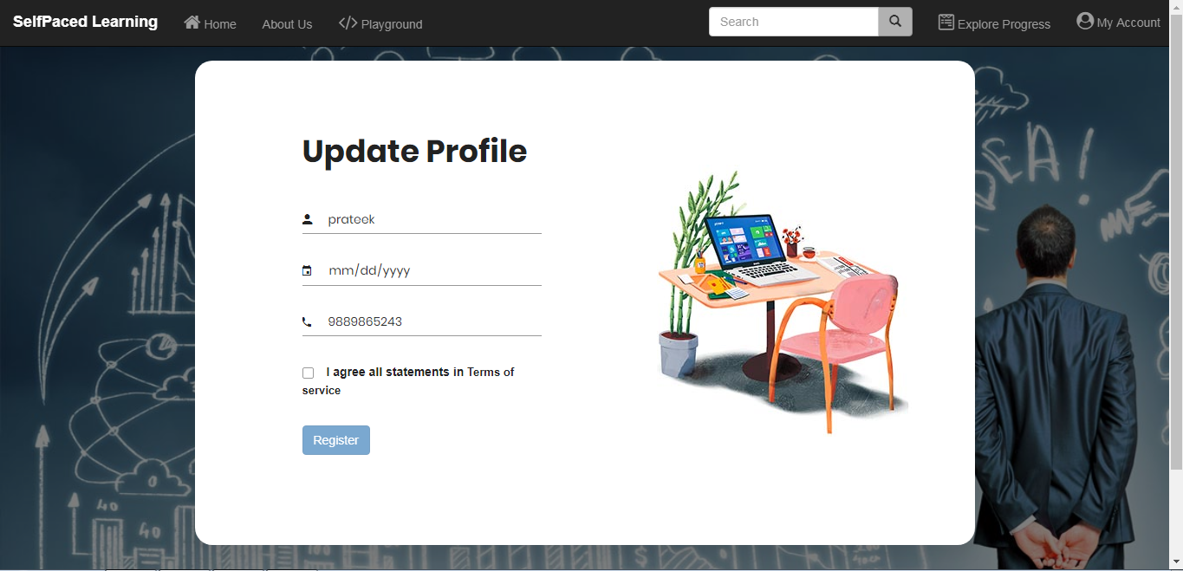

**Feedback:**

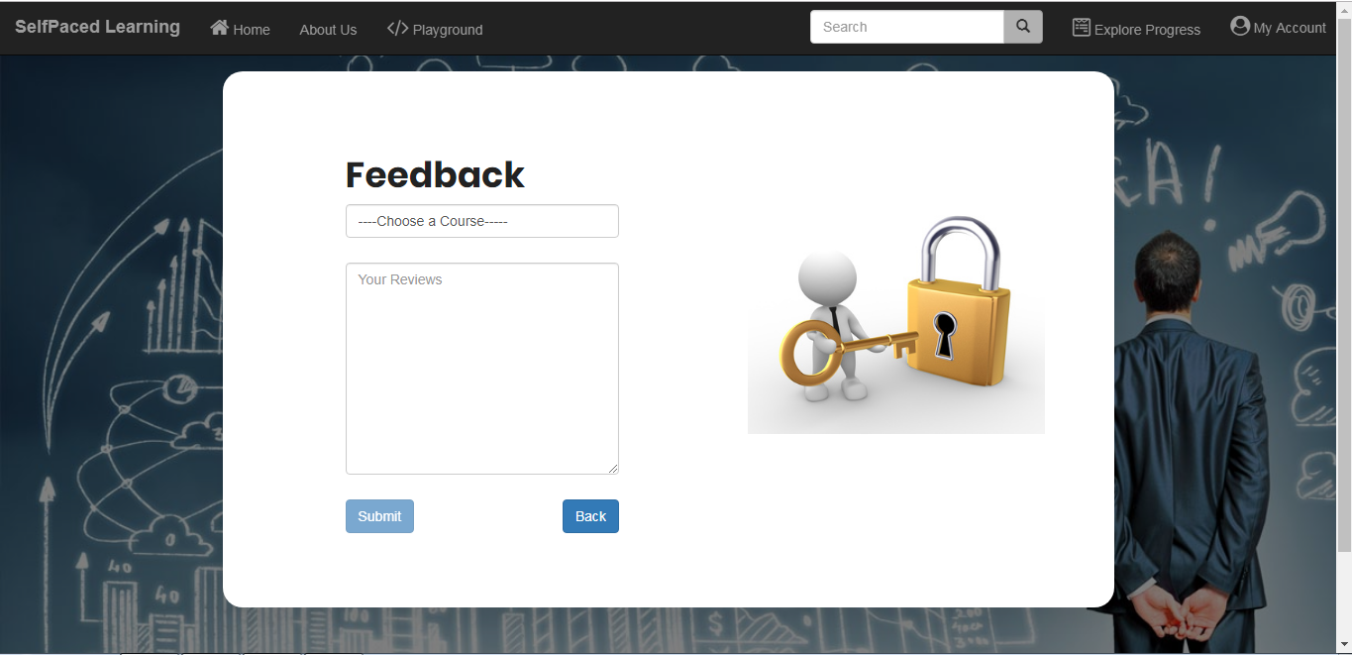

**Sign Out:**

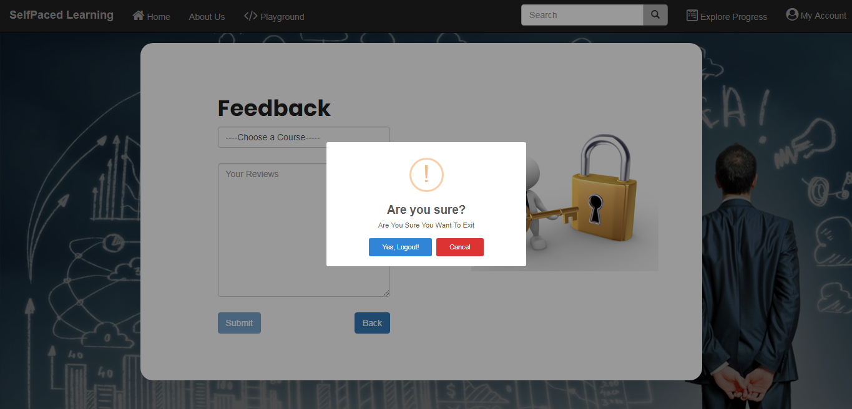

**Admin Login:**

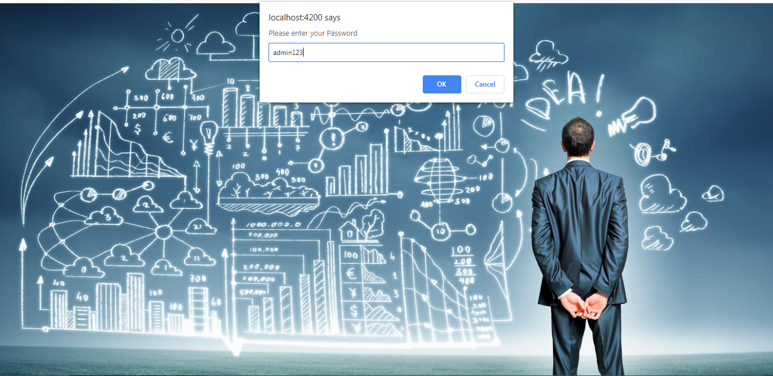

**Employee Details:**

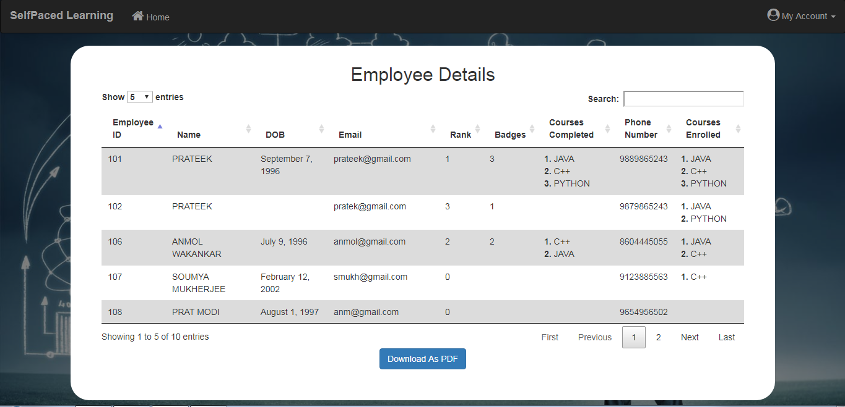

**Feedback Details:**

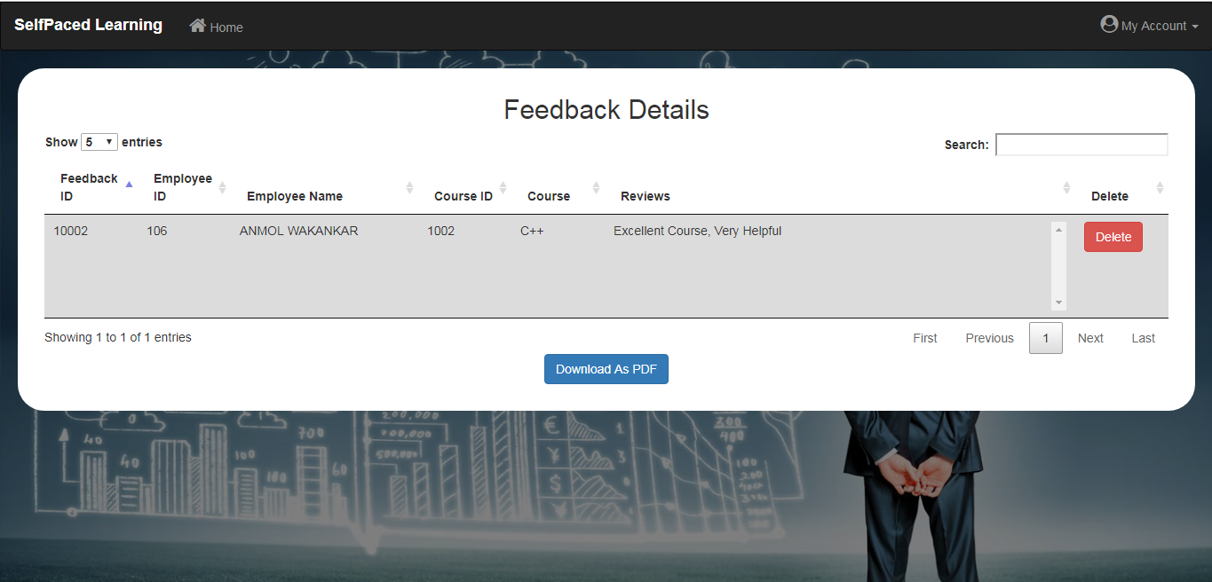

**Course Details:**

